**OUTREACH SCHOOLS EXAMINATION BOARD**

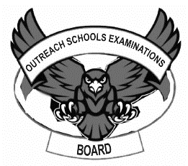 **END OF TERM II EXAMINATION 2024**

**TOP CLASS: (5 – 6 YEARS)**

**LEARNING AREA 4: MATHEMATICAL CONCEPTS**

**My name is: ………………………………..………………………….**

**My School is: ……………………………..……….…………………..**

**I am in: ………………………………..…………………………………………..**

1. **Read and draw these pictures.**

1 cat on a stool.

5 balls in a basket.

3 sticks in a cup.

4 books on a table.

2 pencils in a tin.

1. **Write (half, full, empty)**

half empty full

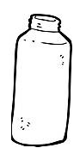

_______ _______ _______

_______ _______ _______

1. **Write the numbers 11 – 25.**

|  |  |  |  |  |
| --- | --- | --- | --- | --- |
| 11 |  |  |  |  |
|  |  |  |  |  |
|  |  |  |  | 25 |

1. **Name the shapes.**

__________ __________

_________ __________

_________ ________

___________ __________

(heart, oval, rectangle, triangle, cone, kite, square)

1. **Add these.**

5 + 6 = 11 2 + 6 = _______

12 + 7 = _____ 4 + 2 = ______

10 + 4 = _____ 11 + 6 = ______

3 + 3 = ______ 5 + 10 = _____

**END**